The united Organizing Committee warmly invite you to participate in joined conferences: XIV International Conference of Mineral Processing and XLVI Symposium on Physicochemical Problesm of Mineral Processing, which will be held 16-18 of September, 2009 in Krakow-Niepołomice.


First Circular

XIV INTERNATIONAL CONFERENCE OF MINERAL PROCESSING

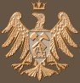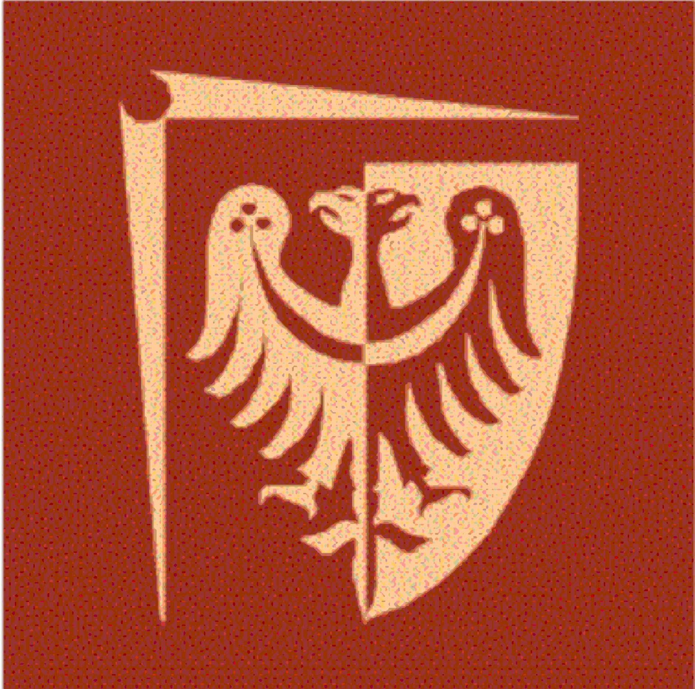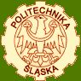

XLVI SYMPOSIUM
PHYSICOCHEMICAL PROBLEMS OF MINERAL PROCESSING

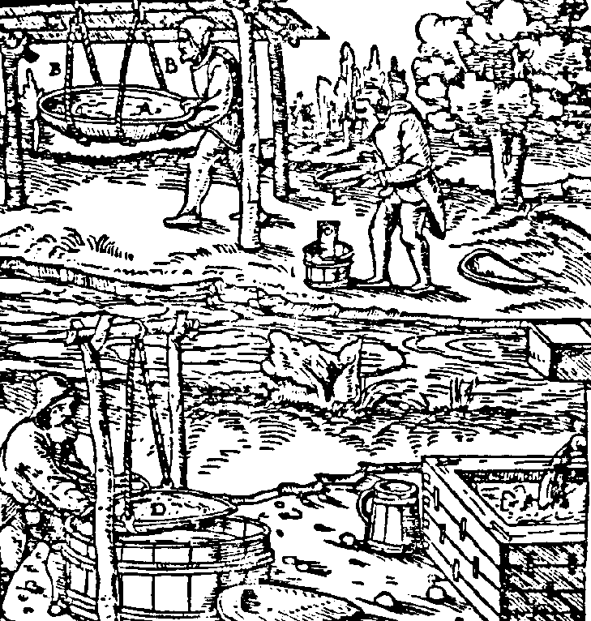

Kraków-Niepołomice
September 16-18, 2009

Organizers
AGH University of Science and Technology
Department of Mineral Processing and
Environmental Protection

Wroclaw University of Technology
Department of Mining Engineering

Silesian University of Technology
Department of Mineral Processing and Waste
Utilization
Polish Academy of Science
Committee of Mining, Section of Mineral Raw
Materials Utilization


The joined conferences provide a great opportutnity to meet representatives of science and industry working with mineral processing, raw materials utilization and ecology.
The papers of the conference will be published in the Górnictwo i Geoinżynieria quarterly and volume 44 of the Physicochemical Problems of Mineral Processing annual before the conference.
The registration fee is 300 EURO per person. The fee covers room, board and conference proceedings. The cost for accompanying person is 250 EURO.
Detailed information about the conference program will be provided in the second circular which will be distributed in June 2009.

CALL FOR PAPERS
The papers should deal with widely understood mineral processing and physicochemical bases of minerallurgical processes, bio- and hydrmetallurgy, ecology etc. The papers can be either basic or practical in the character.
Please send an abstract of your paper to the mentioned above journals (title+abstract, up to 250 words) before March 15, 2009.
The corrected and accepted for publication papers should be sent to the editor before April 15, 2009.
The papers for Physicochemical Problems of Mineral Processing should be written in English and the papers for the Górnictwo i Geoinżynieria quarterly in either Polish or English.
The papers written in Polish must contain title and abstract in English. The caption of figures and tables of papers in Polish should both in Polish and English. The papers should not contain more than 10 pages (Times New Roman 12, interspace 1,5).
The papers will be reviewed according to the rules of both journals. The ones qualified for printing, after being reviewed and eventually revised, written in MS Word must be returned to the Editorial Offices in electronic version together with pronted one or by e-mail before 15 of May, 2009.
Together with final version of the paper, the amount of 300 EURO should be sent for the printing costs. This amount will be subtracted from the full registration fee. All of fees should be paid to bank account given below.

Bank Name: Bank PeKaO S.A. I O/Kraków
Account No: 06 1240 1431 1111 0000 1045 2923
Account Name: Fundacja „Nauka i Tradycje Górnicze”

Please add the foot-note:
Przeróbka Kopalin 2009, name of participant

The papers for Physicochemical Problems of Mineral Processing should be sent to:

Prof. Z. Sadowski, Wroclaw University of Technology
Institute of Chemical Engineering,
Wybrzeże Wyspiańskiego 27, 50-370 Wrocław
e-mail: zygmunt.sadowski@pwr.wroc.pl,
tel.: +48 (71) 320 38 63 or +48 (71) 320-68-79,
or +48 (71) 320-68-78, fax: +48 (71) 344-81-23

Papers for Zeszyty Naukowe AGH
should be sent to:
Dr Tomasz Niedoba
AGH University of Science and Technology
Faculty of Mining and Geoengineering
Department of Mineral Processing and Environmental Protection
Al. Mickiewicza 30, 30-347 Kraków
e-mail:tniedoba@agh.edu.pl
ph.: +48 (12) 617-20-56 or +48 (12) 617-21-73
or
Dr Agnieszka Surowiak
e-mail:asur@agh.edu.pl
ph. +48 (12) 617-20-53

Organizing Committee
Prof. dr Tadeusz Tumidajski –chairman
Dr Tomasz Niedoba– v-ce chairman
Dr Tomasz Gawenda – editor
Dr Agnieszka Surowiak – secretary
Dr Edyta Wójcik-Osip – secretary
AGH University of Science and Technology
Faculty of Mining and Geoengineering
Department of Mineral Processing
and Environmental Protection
al. Mickiewicza 30, 30-347 Kraków, Poland
tel. +48 (12) 617-20-54, +48 (12) 617-20-56
fax: +48 (12) 617-21-98
e-mail: tniedoba@agh.edu.pl or asur@agh.edu.pl
Editors of Physicochemical Problems of Mineral Processing
Prof. Z. Sadowski, zygmunt.sadowski@pwr.wroc.pl
Prof. J. Drzymała, jan.drzymala@pwr.wroc.pl
Prof. A. Łuszczkiewicz, andrew@pwr.wroc.pl

IMPORTANT DATES
March 15, 2009 – abstract submission
April 15, 2009 – accepted papers submission
May 15, 2009 – reviewed and revised papers submission
June 30, 2009 – second circular with conference program appears

SCIENTIFIC COMMITTEE OF THE CONFERENCE

Chairman: Prof. dr Kazimierz Sztaba, AGH
Kraków
Honourable chairman: Prof. dr Andrzej Pomianowski
Polish Academy of Science, Kraków

Members

Prof. dr Wiesław Blaschke, Polish Academy of Science, Kraków
Prof. dr Marian Brożek, AGH, Kraków
Prof. dr Witold Charewicz, Wroclaw Univ. of Techn., Wrocław
Prof. dr Stanisław Chibowski, University of M.Curie, Lublin
Dr Tomasz Chmielewski, Wroclaw Univ. of Techn., Wrocław
Prof. dr Stanisław Cierpisz, Silesian Univ. of Techn., Gliwice
Prof. dr Beata Cwalina, Silesian Medical Academy, Katowice
Prof. dr Jan Drzymała, Wroclaw Univ. of Techn., Wrocław
Prof. dr Janusz Girczys, Czestochowa Univ. of Techn., Czesctochowa
Prof. dr Andrzej Heim, Lodz Univ. of Techn., Łódź
Prof. dr Jan Hupka, Gdansk Univ. of Techn., Gdańsk
Prof. dr Andrzej Krysztafkiewicz, Poznan Univ. of Techn., Poznań
Prof. dr Aleksander Lutyński, Silesian Univ. of Techn., Gliwice
Prof. dr Andrzej Łuszczkiewicz, Wroclaw Univ. of Techn., Wrocław
Prof. dr Kazimierz Małysa, Polish Academy of Science, Kraków
Prof. dr Jolanta Marciniak-Kowalska, AGH, Kraków
Prof. dr Paweł Nowak, Polish Academy of Science, Kraków
Prof. dr Jerzy Sablik, Main Inst. of Mining, Katowice
Prof. dr Zygmunt Sadowski, Wroclaw Univ. of Techn., Wrocław
Prof. dr Barbara Tora, AGH, Kraków
Prof. dr Stanislawa Sanak-Rydlewska, AGH, Kraków
Prof. dr Kazimierz Trybalski, AGH, Kraków
Prof. dr Tadeusz Tumidajski, AGH, Kraków

INTERNATIONAL SCIENTIFIC COMMITTEE
Prof. dr Janusz Laskowski, UBC, Canada
Prof. Peter Fečko, Techn. University Ostrava, Czech Republic
Dr Krystyna Gawor-Kuchta, Australia
Prof. dr Rudolf A. Tomanec, Belgrade University, Serbia
Prof. dr B. Csoke, Univ. of Miskolc, Hungary
Prof. dr J. I. Antonow, Dnepropetrovsk Mining Inst., Ukraine
Prof. dr Dmitrij V. Chekhiriew, Moscow State Inst., Russia
Prof. dr J. Matschullat, TU Bergakademie Freiberg, Germany
Prof. dr Józef Mačala, Tech. University Kosice, Slovakia

Prof. dr Ashraf Amer, Alexandria University, Egypt

APPLICATION FORM
XIV International Conference of Mineral Processing and XLVI Symposium
„Physicochemical Problems of Minerallurgy”
Kraków,16-18.09.2009

Name, titles: ........................................................................................
........................................................................................
Name and work or home address: .........................................................................................
.........................................................................................
.........................................................................................
Phone number: ..............................................................
fax: ..................................................................................
e-mail ..............................................................................
Fee:
.... 300 EURO full participation
...... 250 EURO accompanying person
...... 150 EURO printing fee *
................... total
was / will be paid on day .........................................on account:
Fundacja „Nauka i Tradycje Górnicze”
Bank PeKaO S.A. I/O/Kraków
Nr: 06 1240 1431 1111 0000 1045 2923
With a foot-note: Przeróbka Kopalin 2009, name of participant
We authorize Foundation „Nauka i Tradycje Górnicze” by AGH to prepare a VAT invoice without signature of recipient
Tax identification number: ...........................................................
............................... .................. .........................
City date signature
............................... .................................
main accountant signature principal signature
________________________
Attention! The fee is collected when paper is printed without paritcipation in the conference

APPLICATION FORM
XIV International Conference of Mineral Processing and XLVI Symposium „Physicochemical Problems of Minerallurgy”
Kraków,16-18.09.2009

Name, titles: ........................................................................................
........................................................................................
Name and work or home address: .........................................................................................
.........................................................................................
.........................................................................................
Phone number: ..............................................................
fax: ..................................................................................
e-mail ..............................................................................
Fee:
.... 300 EURO full participation
...... 250 EURO accompanying person
...... 150 EURO printing fee *
................... total
was / will be paid on day .........................................on account:
Fundacja „Nauka i Tradycje Górnicze”
Bank PeKaO S.A. I/O/Kraków
Nr: 06 1240 1431 1111 0000 1045 2923
With a foot-note: Przeróbka Kopalin 2009, name of participant
We authorize Foundation „Nauka i Tradycje Górnicze” by AGH to prepare a VAT invoice without signature of recipient
Tax identification number: ...........................................................
............................... .................. .........................
City date signature
............................... .................................
main accountant signature principal signature
________________________
Attention! The fee is collected when paper is printed without paritcipation in the conference

APPLICATION FORM
XIV International Conference of Mineral Processing and XLVI Symposium
„Physicochemical Problems of Minerallurgy”
Kraków,16-18.09.2009

Name, titles: ........................................................................................
........................................................................................
Name and work or home address: .........................................................................................
.........................................................................................
.........................................................................................
Phone number: ..............................................................
fax: ..................................................................................
e-mail ..............................................................................
Fee:
.... 300 EURO full participation
...... 250 EURO accompanying person
...... 150 EURO printing fee *
................... total
was / will be paid on day .........................................on account:
Fundacja „Nauka i Tradycje Górnicze”
Bank PeKaO S.A. I/O/Kraków
Nr: 06 1240 1431 1111 0000 1045 2923
With a foot-note: Przeróbka Kopalin 2009, name of participant
We authorize Foundation „Nauka i Tradycje Górnicze” by AGH to prepare a VAT invoice without signature of recipient
Tax identification number: ...........................................................
............................... .................. .........................
City date signature
............................... .................................
main accountant signature principal signature
________________________
Attention! The fee is collected when paper is printed without paritcipation in the conference

